## PROGRAM DEFINITION

|  |
| --- |
|  |
| * A program to generate a report for a list of outstanding penalty amounts per-agreement |

## RELATED TABLES

|  |  |
| --- | --- |
|  | **Access** |
| * - | * - |

## ROLES

|  |  |
| --- | --- |
|  | **Test** |
| * User that has access to program |  |

## INITIAL PROCESS

|  |  |
| --- | --- |
|  | **Test** |
| * Set VAR_COMPANY_ID = Login User’s Company ID * Set VAR_USER_ID = Login User’s ID * Set VAR_LANGUAGE_ID = Login User’s Language ID * Execute this stored procedure, save the results to VAR_YEAR_RANGE   EXEC RSP_GS_GET_PERIOD_YEAR_RANGE  VAR_COMPANY_ID  , ''  , ''   * Set VAR_LOOKUP_CUSTOMER_LIST_GET_RECORD = Value from lookup PML00600 with the following parameters: * VAR_COMPANY_ID * selected Property ID * “01” * VAR_USER_ID * - |  |

## MAIN FORM

### USER INTERFACE

#### INITIAL VERSION

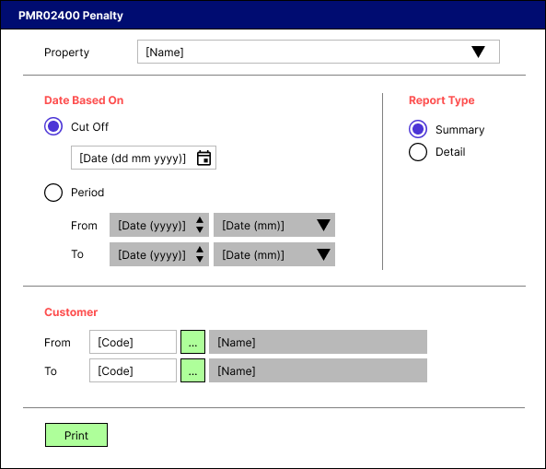

### BUTTON DEFINITION

|  |  |
| --- | --- |
| **Button Name** | **Action** |
| Print | Run PRINT REPORT PROCESS |

### DISPLAY PROCESS

#### FIELD DEFINITION

|  |  |  |  |
| --- | --- | --- | --- |
| **Name** | **Field** | **Type** | **Validation** |
| Property |  | Combo box  Set VAR_PROPERTY_LIST with  EXEC RSP_GS_GET_PROPERTY_LIST  VAR_COMPANY_ID  , VAR_USER_ID  Set property id = CPROPERTY_ID  Set property name = CPROPERTY_NAME  Set default selected property id = top 1 property id from VAR_PROPERTY_LIST.  Show name from the specific property id | * Mandatory * - |
| Date Based On |  | Radio button  Radio Value   * ‘1’ = Cut Off * ‘2’ = Period   Set default value to Cut Off | * Mandatory * If selected value = Cut Off, then: * Enable Date Based On [Cut Off] * Disable Date Based On [Period [From [Year]]] * Disable Date Based On [Period [From [Month]]] * Disable Date Based On [Period [To [Year]]] * Disable Date Based On [Period [To [Month]]] * Else: * Disable Date Based On [Cut Off] * Enable Date Based On [Period [From [Year]]] * Enable Date Based On [Period [From [Month]]] * Enable Date Based On [Period [To [Year]]] * Enable Date Based On [Period [To [Month]]] * - |
| Date Based On [Cut Off] |  | Date picker  Set default value:  SELECT dbo.RFN_GET_DB_TODAY (VAR_COMPANY_ID) | * Mandatory, if Date Based On = ‘1’ * - |
| Date Based On [Period [From [Year]]] |  | Spinner  Spinner value:   * Minimum = VAR_YEAR_RANGE.IMIN_YEAR * Maximum = VAR_YEAR_RANGE.IMAX_YEAR   Set default spinner value:  SELECT YEAR(dbo.RFN_GET_DB_TODAY (VAR_COMPANY_ID)) | * Mandatory, if Date Based On = ‘2’ * - |
| Date Based On [Period [From [Month]]] |  | Combo box  Set VAR_PERIOD_MONTH_LIST (as array of object) with VAR_MONTH_NUMBER and VAR_MONTH_NAME.  Set VAR_MONTH_NUMBER = 01, 02, … , 12  Set VAR_MONTH_NAME = January, February, … , December  Set default combo box value month name based on  SELECT MONTH(dbo.RFN_GET_DB_TODAY (VAR_COMPANY_ID)) | * Mandatory, if Date Based On = ‘2’ * - |
| Date Based On [Period [To [Year]]] |  | Spinner  Spinner value:   * Minimum = VAR_YEAR_RANGE.IMIN_YEAR * Maximum = VAR_YEAR_RANGE.IMAX_YEAR   Set default spinner value:  SELECT YEAR(dbo.RFN_GET_DB_TODAY (VAR_COMPANY_ID)) | * Mandatory, if Date Based On = ‘2’ * - |
| Date Based On [Period [To [Month]]] |  | Combo box  Set VAR_PERIOD_MONTH_LIST (as array of object) with VAR_MONTH_NUMBER and VAR_MONTH_NAME.  Set VAR_MONTH_NUMBER = 01, 02, … , 12  Set VAR_MONTH_NAME = January, February, … , December  Set default combo box value month name based on  SELECT MONTH(dbo.RFN_GET_DB_TODAY (VAR_COMPANY_ID)) | * Mandatory, if Date Based On = ‘2’ * - |
| Report Type |  | Radio button  Radio Value   * ‘1’ = Summary * ‘2’ = Detail   Set default value to Summary | * Mandatory * - |
| Customer [From [Code]] |  | Text box | * Mandatory * After being changed, then check its name based on VAR_LOOKUP_CUSTOMER_LIST_GET_RECORD and save it to VAR_CUSTOMER_NAME. Finally: * If VAR_CUSTOMER_NAME is empty, then: * Display message “Customer [INPUT Customer Code] not found!”, [OK] * Set focus to Customer [From [Code]] field * Else, set Customer [From [Name]]’s value = VAR_CUSTOMER_NAME * - |
| Customer [From [Lookup]] |  | Lookup | * Enter lookup program PML00600 with parameters: * VAR_COMPANY_ID * selected Property ID * “01” * VAR_USER_ID   Then save the result to VAR_CUSTOMER_RESULT   * If VAR_CUSTOMER_RESULT is empty, then: * Display message “Customer [INPUT Customer Code] not found!”, [OK] * Set focus to Customer [From [Code]] field * Else if VAR_CUSTOMER_RESULT exists, then: * Set Customer [From [Code]] = CTENANT_ID * Set Customer [From [Name]] = CTENANT_NAME * - |
| Customer [From [Name]] |  | Text box | * Disabled * - |
| Customer [To [Code]] |  | Text box | * Mandatory * After being changed, then check its name based on VAR_LOOKUP_CUSTOMER_LIST_GET_RECORD and save it to VAR_CUSTOMER_NAME. Finally: * If VAR_CUSTOMER_NAME is empty, then: * Display message “Customer [INPUT Customer Code] not found!”, [OK] * Set focus to Customer [To [Code]] field * Else, set Customer [To [Name]]’s value = VAR_CUSTOMER_NAME * - |
| Customer [To [Lookup]] |  | Lookup | * Enter lookup program PML00600 with parameters: * VAR_COMPANY_ID * selected Property ID * “01” * VAR_USER_ID   Then save the result to VAR_CUSTOMER_RESULT   * If VAR_CUSTOMER_RESULT is empty, then: * Display message “Customer [INPUT Customer Code] not found!”, [OK] * Set focus to Customer [To [Code]] field * Else if VAR_CUSTOMER_RESULT exists, then: * Set Customer [To [Code]] = CTENANT_ID * Set Customer [To [Name]] = CTENANT_NAME * - |
| Customer [To [Name]] |  | Text box | * Disabled * - |

### PRINT REPORT PROCESS

#### REPORT LAYOUT

PAPER SIZE: A4 PORTRAIT

FONT SIZE: 7

REPORT TYPE: SUMMARY

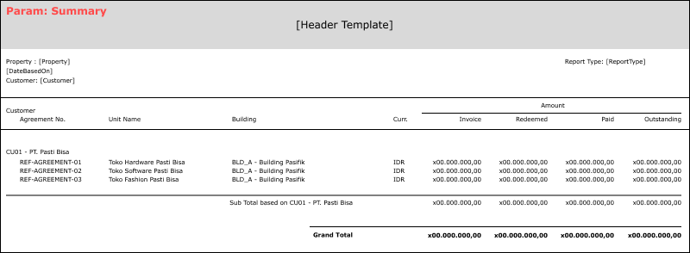

PAPER SIZE: A4 LANDSCAPE

FONT SIZE: 7

REPORT TYPE: DETAIL

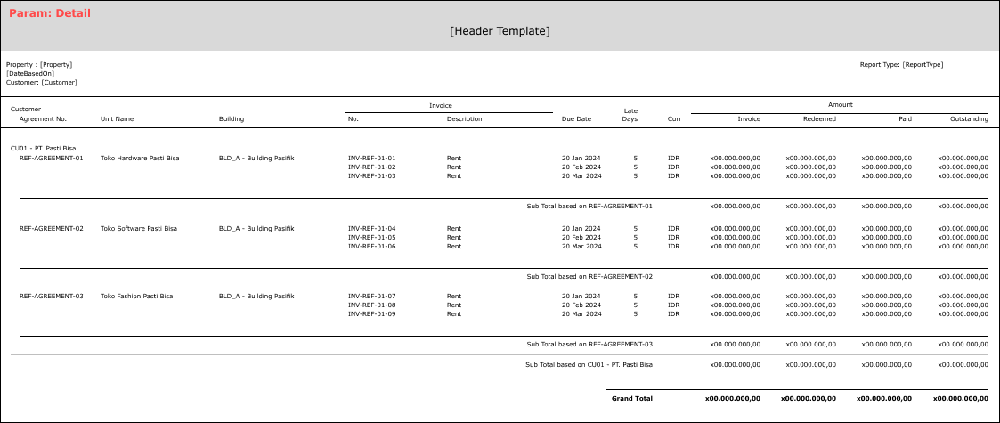

#### REPORT DEFINITION

REPORT SECTION FOR HEADER (ALL REPORTS)

|  |  |  |  |
| --- | --- | --- | --- |
| **Section** | **Name** | **Field** | **Validation** |
| HEADER | Property | Selected Property | Show Property ID – Property Name  Ex. “ABCDE – Global Property” |
| Date Based On | Selected Date Based On | If Date Based On = ‘1’, then:   * Show “Cut Off Date: ” concatenate with: * If there is no date standardization, then use format “dd Mon yyyy” for Date Cut Off   Ex. “14 Sep 2001”   * Else, use date standardization * Concatenate the validation above into   “Cut Off Date: 14 Sep 2001”  Else if Date Based On = ‘2’, then:   * Show “Period: ” concatenate with: * If Date Based On [Period [From]] <> Date Based On [Period [To]], then show “MMM yyyy – MMM yyyy”   Ex. Date Based On [Period [From]] = “200109” and Date Based On [Period [To]] = “200110”, then show “September 2001 – October 2001”   * Else, show “MMM yyyy"   Ex. Date Based On [Period [From]] = “200109” and Date Based On [Period [To]] = “200109”, then show “September 2001”   * - * Concatenate the validation above into “Period: September 2001 – October 2001” |
| Customer | Selected Customer | Show only when Based On = ‘1’  IF Customer [From [Code]] <> Customer [To [Code]], then “Customer [From [Name]] (Customer [From [Code]]) – Customer [To [Name]] (Customer [To [Code]])”  ELSE, “Customer [From [Name]] (Customer [From [Code]])”  Ex. 1  Selected from: MU01 – Andika Putra  Selected to: AE01 – Aurerius Irvin  Hence, show “Andika Putra (MU01) – Aurerius Irvin (AE01)”  Ex. 2  Selected from: MU01 – Andika Putra  Selected to: MU01 – Andika Putra  Hence, show “Andika Putra (MU01)” |
| Report Type | Selected Report Type | Show Report Type’s value  Ex. “Summary” |

REPORT SECTION FOR SUMMARY

|  |  |  |  |
| --- | --- | --- | --- |
| **Section** | **Name** | **Field** | **Validation** |
| REPORT GROUP | Customer | CTENANT_ID |  |
| GROUP BY CUSTOMER [HEADER] | Customer | CTENANT_ID - CTENANT_NAME |  |
| DETAIL | Agreement No. | CAGREEMENT_NO |  |
| Unit Name | CUNIT_DESCRIPTION |  |
| Building | CBUILDING_ID - CBUILDING_NAME |  |
| Curr. | CCURRENCY_CODE |  |
| Invoice Amount | NINVOICE_AMOUNT |  |
| Redeemed Amount | NREDEEMED_AMOUNT |  |
| Paid Amount | NPAID_AMOUNT |  |
| Outstanding Amount | NOUTSTANDING_AMOUNT |  |
| GROUP BY CUSTOMER [FOOTER] | Sub Total of Invoice Amount |  | Sum of NINVOICE_AMOUNT |
| Sub Total of Redeemed Amount |  | Sum of NREDEEMED_AMOUNT |
| Sub Total of Paid Amount |  | Sum of NPAID_AMOUNT |
| Sub Total of Outstanding Amount |  | Sum of NOUTSTANDING_AMOUNT |
| SUMMARY | Grand Total of Invoice Amount |  | Sum of NINVOICE_AMOUNT |
| Grand Total of Redeemed Amount |  | Sum of NREDEEMED_AMOUNT |
| Grand Total of Paid Amount |  | Sum of NPAID_AMOUNT |
| Grand Total of Outstanding Amount |  | Sum of NOUTSTANDING_AMOUNT |

REPORT SECTION FOR DETAIL

|  |  |  |  |
| --- | --- | --- | --- |
| **Section** | **Name** | **Field** | **Validation** |
| REPORT GROUP | Customer | CTENANT_ID |  |
| Agreement No. | CAGREEMENT_NO |  |
| GROUP BY CUSTOMER [HEADER] | Customer | CTENANT_ID - CTENANT_NAME |  |
| GROUP BY AGREEMENT NO. [HEADER] | Agreement No. | CAGREEMENT_NO |  |
| Unit Name | CUNIT_DESCRIPTION |  |
| Building | CBUILDING_ID - CBUILDING_NAME |  |
| DETAIL | Invoice No. | CINVOICE_NO |  |
| Invoice Description | CINVOICE_DESCRIPTION |  |
| Due Date | CDUE_DATE |  |
| Late Days | ILATE_DAYS |  |
| Curr. | CCURRENCY_CODE |  |
| Invoice Amount | NINVOICE_AMOUNT |  |
| Redeemed Amount | NREDEEMED_AMOUNT |  |
| Paid Amount | NPAID_AMOUNT |  |
| Outstanding Amount | NOUTSTANDING_AMOUNT |  |
| GROUP BY AGREEMENT NO. [FOOTER] | Sub Total of Invoice Amount |  | Sum of NINVOICE_AMOUNT |
| Sub Total of Redeemed Amount |  | Sum of NREDEEMED_AMOUNT |
| Sub Total of Paid Amount |  | Sum of NPAID_AMOUNT |
| Sub Total of Outstanding Amount |  | Sum of NOUTSTANDING_AMOUNT |
| GROUP BY CUSTOMER [FOOTER] | Sub Total of Invoice Amount |  | Sum of NINVOICE_AMOUNT |
| Sub Total of Redeemed Amount |  | Sum of NREDEEMED_AMOUNT |
| Sub Total of Paid Amount |  | Sum of NPAID_AMOUNT |
| Sub Total of Outstanding Amount |  | Sum of NOUTSTANDING_AMOUNT |
| SUMMARY | Grand Total of Invoice Amount |  | Sum of NINVOICE_AMOUNT |
| Grand Total of Redeemed Amount |  | Sum of NREDEEMED_AMOUNT |
| Grand Total of Paid Amount |  | Sum of NPAID_AMOUNT |
| Grand Total of Outstanding Amount |  | Sum of NOUTSTANDING_AMOUNT |

#### VALIDATION

|  |  |  |
| --- | --- | --- |
| **Field** | **Condition** | **Validation Message** |
| Property | Empty | Please select Property |
| Date Based On | Date Based On = ‘1’ **and** Date Based On [Cut Off] is empty | Please select Cut Off Date |
| Date Based On = ‘2’ **and** **(**Date Based On [Period [From [Year]]] is empty **or** Date Based On [Period [From [Month]]] is empty **or** Date Based On [Period [To [Year]]] is empty **or** Date Based On [Period [To [Month]]] is empty**)** | Please select Period |
| Date Based On = ‘2’ **and** Date Based On [Period [From]] > Date Based On [Period [To]] | Period (From) cannot be more than Period (To) |
| Customer | Customer [From [Code]] is empty **or** Customer [To [Code]] is empty | Please select Customer |

#### ACTION

|  |
| --- |
|  |
| * Execute this stored procedure:   RSP_PMR02400_GET_REPORT  VAR_COMPANY_ID  , selected Property ID  , selected Cut Off  , selected Period [From]  , selected Period [To]  , selected Report Type  , selected Customer [From [Code]]  , selected Customer [To [Code]]  , VAR_LANGUAGE_ID  Note for sending those parameters to execute the stored procedure above:   * If selected Date Based On = ‘1’, then empty these values: * Selected Period [From] * Selected Period [To]   Else if selected Date Based On = ‘2’, then empty these values:   * Selected Cut Off * Selected Cut Off’s value should be “yyyymmdd” * Selected Period [From]’s value should be “yyyymm” * Selected Period [To]’s value should be “yyyymm” * **!IMPORTANT!: DIFFERENT SELECTED REPORT TYPE RESULTING IN DIFFERENT OUTPUT** * Ex. 1 for Summary [THERE IS CURRENTLY NO AVAILABLE DATA // TABLE IS NOT EXISTS]   EXEC RSP_PMR02400_GET_REPORT  ''  , ''  , ''  , ''  , ''  , '1'  , ''  , ''  , ''   * Ex. 2 for Detail [THERE IS CURRENTLY NO AVAILABLE DATA // TABLE IS NOT EXISTS]   EXEC RSP_PMR02400_GET_REPORT  ''  , ''  , ''  , ''  , ''  , '2'  , ''  , ''  , ''   * - |

# CR LIST

|  |  |  |
| --- | --- | --- |
| **CR** | **Description** | **Notes** |
|  |  |  |

#### TEMPLATE

#### VALIDATION

|  |  |  |
| --- | --- | --- |
| **Field** | **Condition** | **Validation Message** |
|  |  |  |
|  |  |  |

#### ACTION

|  |
| --- |
|  |
|  |